**Developer’s Guide:**

**Software**: Visual Studio 2022.

* Download source code via link: [*https://github.com/bobu1907/eproject3*](https://github.com/bobu1907/eproject3)
* How to import if you don't understand my word: https://youtu.be/XLzV_gagkZc?si=9jA-KrNBxxEBa0W0

**Database**:

* Microsoft SQL Server Management Studio 18 (SQL Server 2019).
* Run a database: open file ProjectS3.sql and Execute it to get a database first

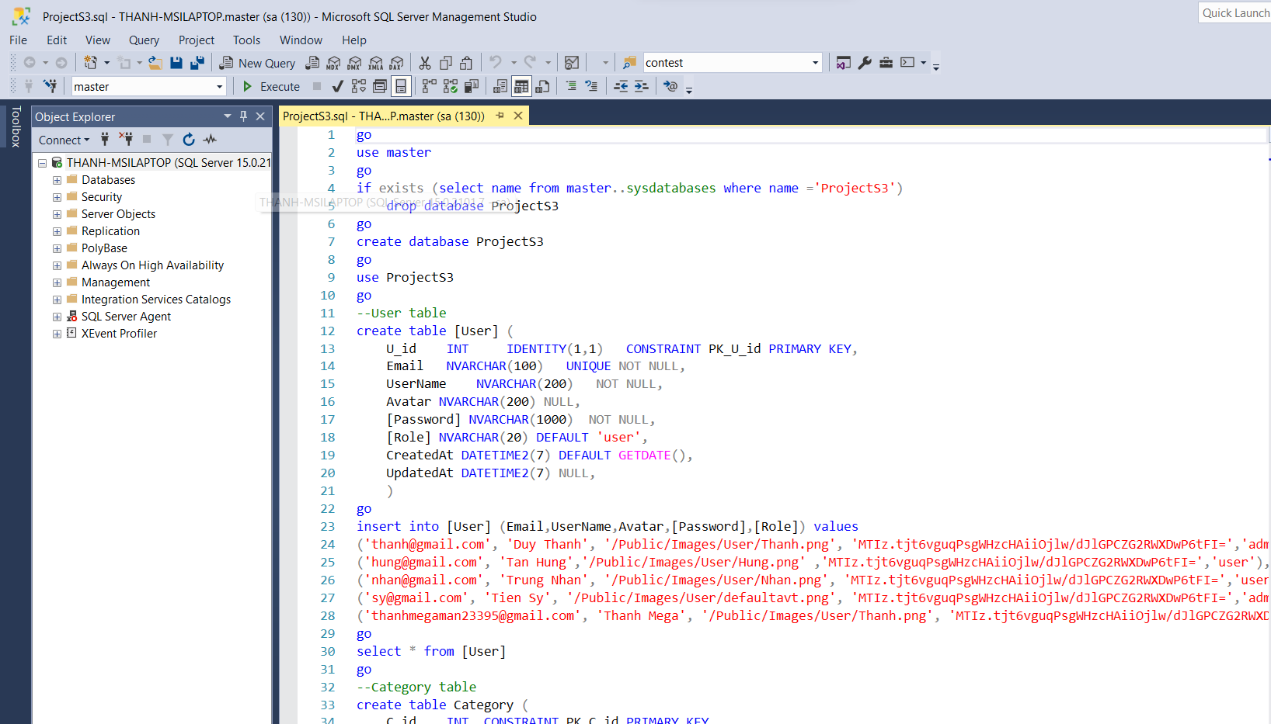

**Run backend:**

* Extract file. Open folder backend and run file backend.sln by Visual Studio 2022

**Connect SQL Server:**

***Case 1:***

* Get connection string: View/Server Explorer. Connect to dataabase 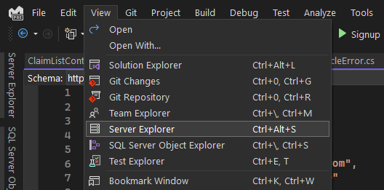 A screenshot of a computer

  Description automatically generated
* Find and search your server database in SQL Server Management 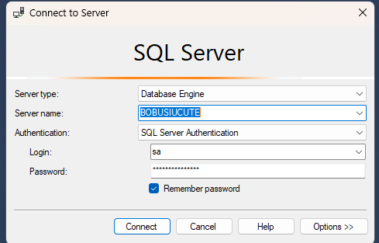
* After connect your server database. Choose add connection… A screenshot of a computer

  Description automatically generated
* Choose SQL server…
* A screenshot of a computer

  Description automatically generated
* Add and test your connection A screenshot of a computer

  Description automatically generated
* Find your connection string here A screenshot of a computer

  Description automatically generated

***Case 2:***

* Just change your connection string (server, database, user id, password,…) like this form
* Hit run button have green color





Check the package version if it’s necessary 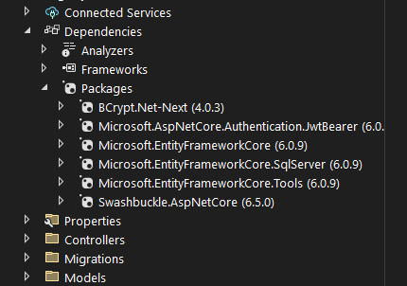

**Run frontend:**

* Install Nodejs v16.14.2 (important). And check there some version of react A computer screen shot of a black screen

  Description automatically generated
* Run Visual Studio Code, open folder frontend. Crl+` to openterminal

* Run code: npm install, then npm start. Please be patience, it will take about 5 minutes to start the frontend server
* If it’s not work. Try: npm install –force
* And finally: Enjoy these cool palm car insurance policies …

**Super Admin account:**

* Username: admin
* Password: 123